All British Car Show Sponsorship Opportunities April 2, 2022
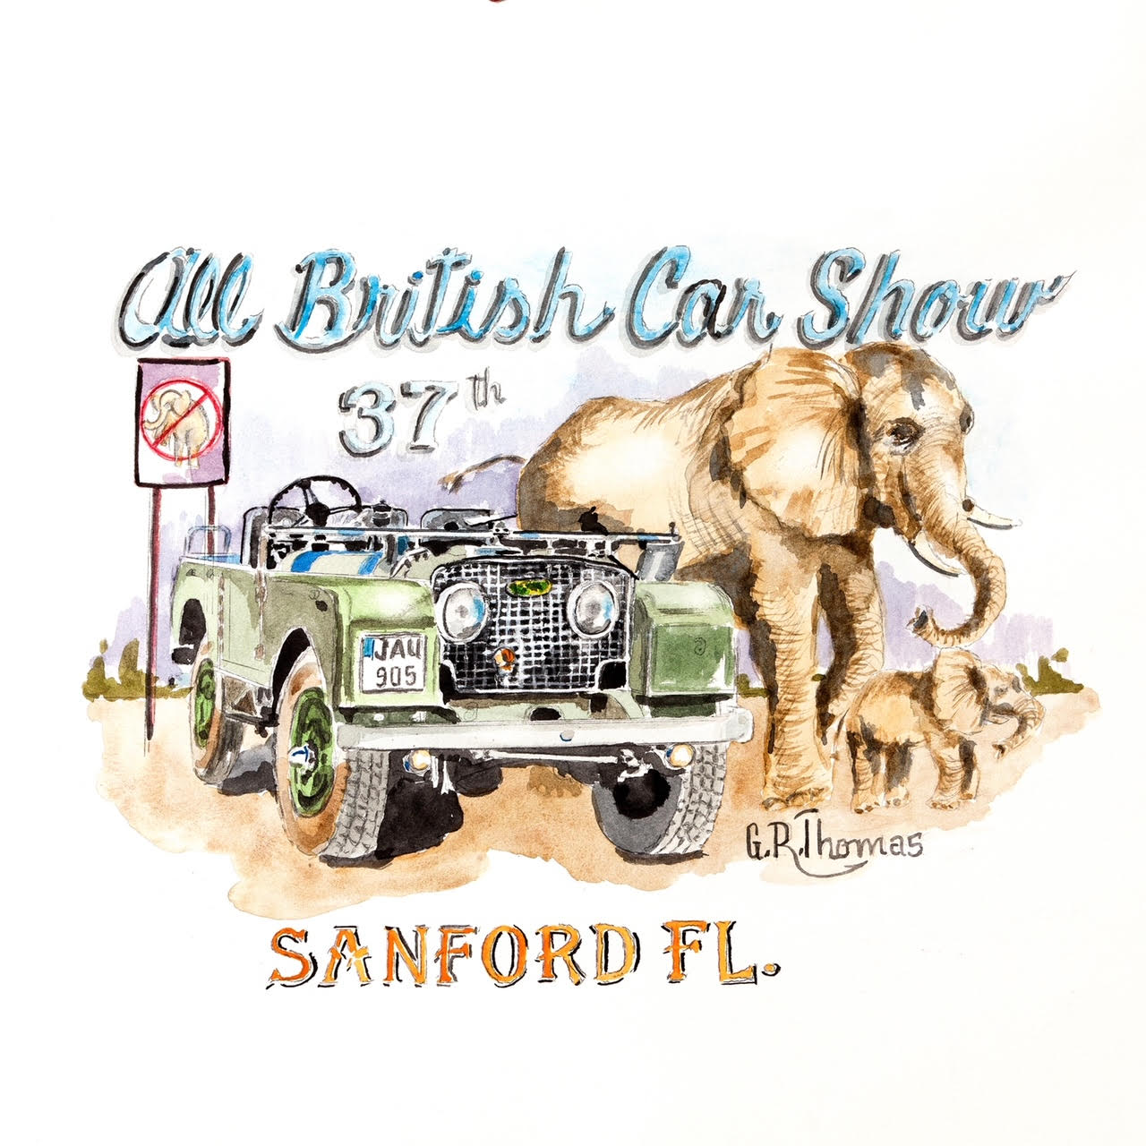
Sponsorship Levels

Platinum $1,000
Sponsorship Benefits
Your logo on event T-shirt
Your logo on event advertisements
Your logo on event flyer handouts
Your logo and website posted for one year on our club website
Free tent booth space to display your produce
Free car entry for event
Free event T-shirt
Sponsor’s Plaque

Gold $500
Sponsorship Benefits
Your logo on event advertisements
Your logo on event flyer handouts
Your logo and website posted for one year on our club website
Free tent booth space to display your product
Free event T-shirt
Sponsor’s Plaque

Silver $250
Sponsorship Benefits
Your logo on event flyer handouts
Your logo and website posted for one year on our club website
Free tent booth space to display your product
Free event T-shirt
Sponsor’s Plaque

Bronze $100
Sponsorship Benefits
Your Company posted on event flyer handout
Your company website posted for one year on our club website
Free tent booth space to display your product

